10. Develop a system using UML for Recruitment System, to recruit the applicant for a particular job in the company. It was controlled by the central management system to manage the details of the particular applicant who has to be recruited by a company.

USE CASE DIAGRAM

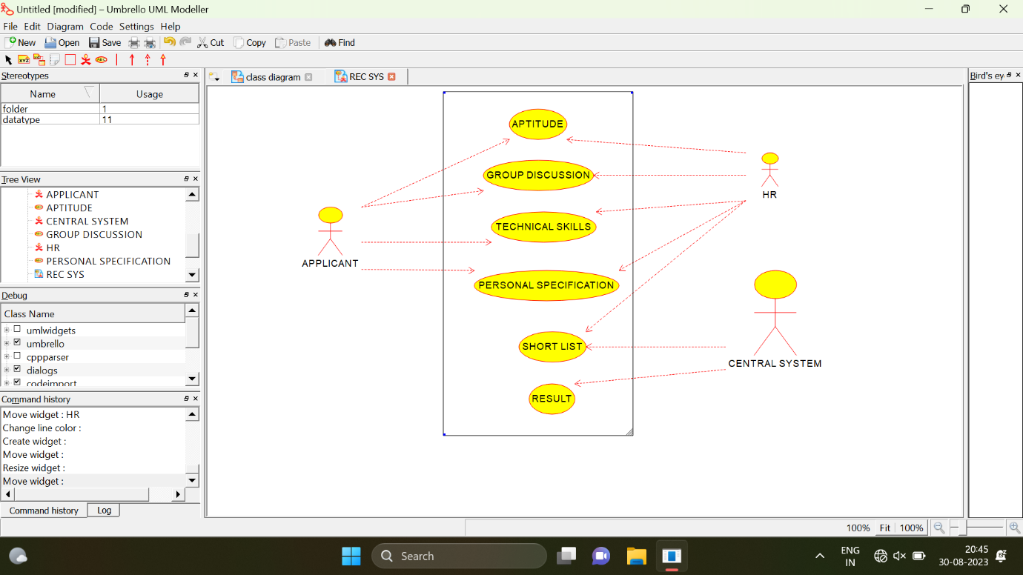

CLASS DIAGRAM

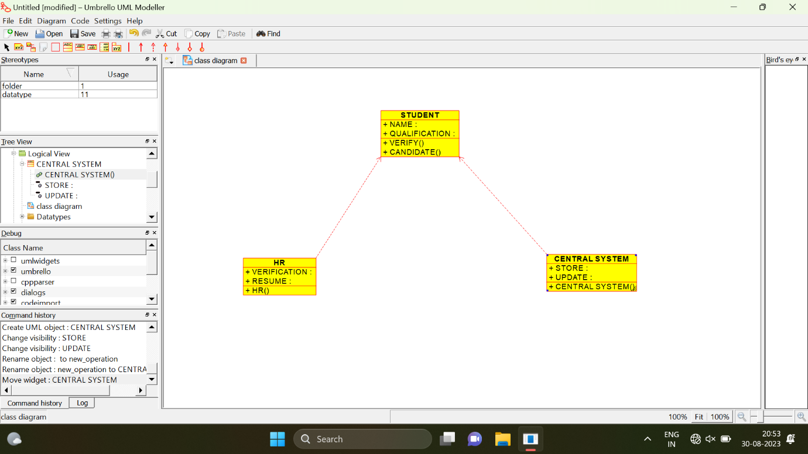

COLLABORATION DIAGRAM

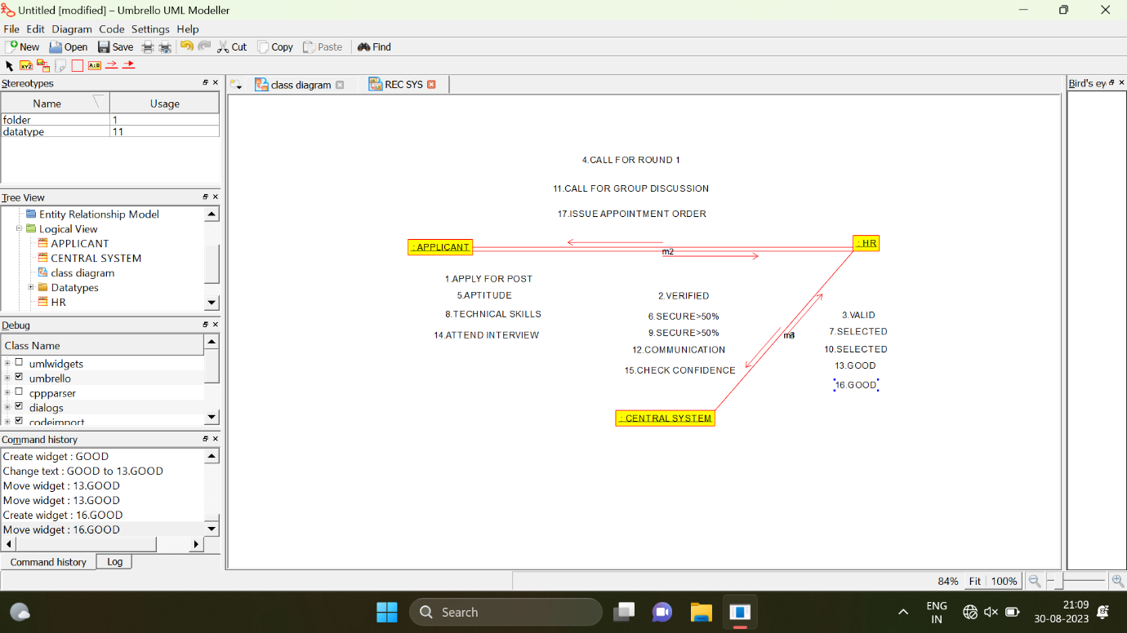

STATE CHART DIAGRAM



